**ActiveX Controls**

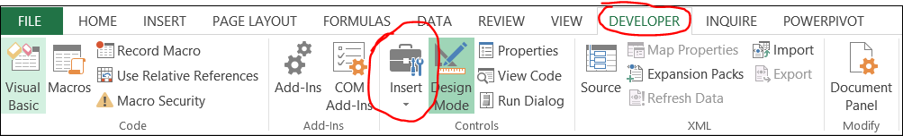

**What is the difference between “Form Controls” and “ActiveX Control” in Excel 2010?**

<http://stackoverflow.com/questions/15455179/what-is-the-difference-between-form-controls-and-activex-control-in-excel-20>

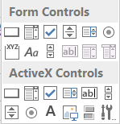

Generally you'll use Forms controls, they're simpler. ActiveX controls allow for more flexible design and should be used when the job just can't be done with a basic Forms control.

Many user's computers by [default won't trust](http://office.microsoft.com/en-us/excel-help/enable-or-disable-activex-controls-in-office-documents-HA010031067.aspx) ActiveX, and it will be disabled; this sometimes needs to be manually added to the trust center. ActiveX is a microsoft-based technology and, as far as I'm aware, is not supported on the Mac. This is something you'll have to also consider, should you (or anyone you provide a workbook to) decide to use it on a Mac.

One major difference is that ActiveX controls show up as objects that you can use in your code- try inserting an ActiveX control into a worksheet, bring up the VBA editor and you will be able to address the control programmatically. You can't do this with form controls, but form controls are easier to use. If you're just doing something simple, it doesn't matter which you use but for some advanced things you will need to use ActiveX. ActiveX is also more customizable.

Double click on the ActiveX control and it rings the code editor:

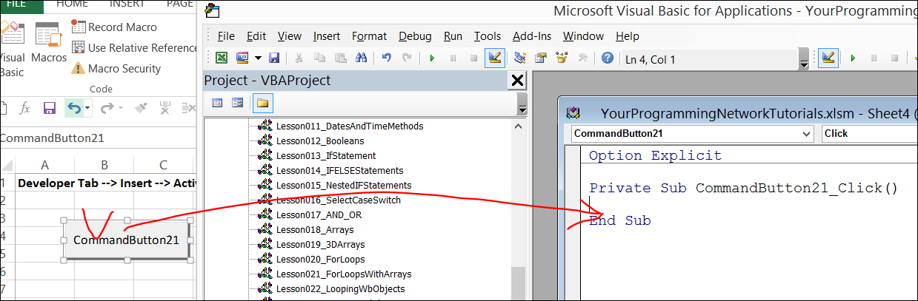

Private Sub CommandButton21_Click()

Call anotherCode()

End Sub

Sub anotherCode()

MsgBox("Hello from another sub!")

End Sub

## **TextBox**

Add Textbox and a Button

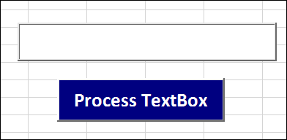

We can link textbox to a cell on the sheet in the TextBox properties (e.g. cell F1 is connected to the TextBox)

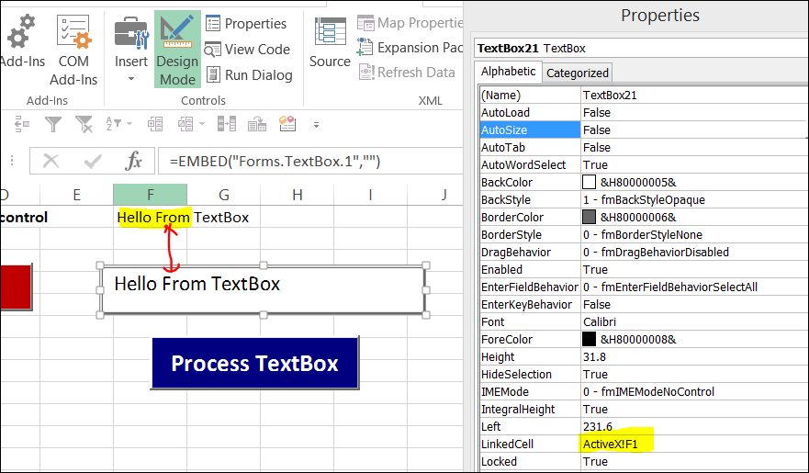

Rename the TextBox in the properties

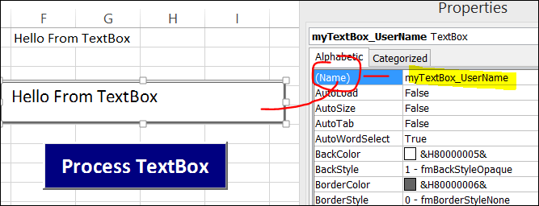

Also rename the Button Name

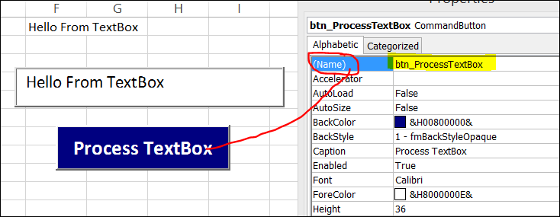

Now double click on the button to create an event and put this code

Private Sub **btn_ProcessTextBox**_Click()

Dim userName As String

userName = ThisWorkbook.Sheets("ActiveX").**myTextBox_UserName**.Value

MsgBox("printing TextBox message: " & userName)

End Sub

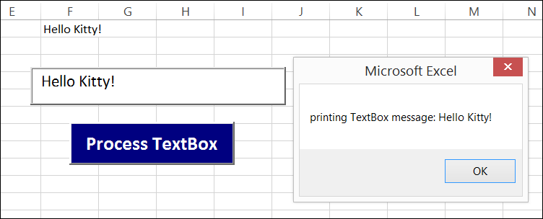

## **DropDown Box**

Add a Combo Box

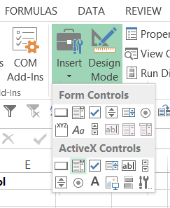

Put the month names in the range

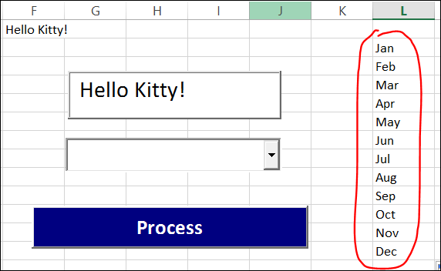

Give a combobox a name

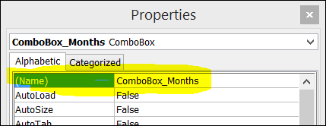

Assign range

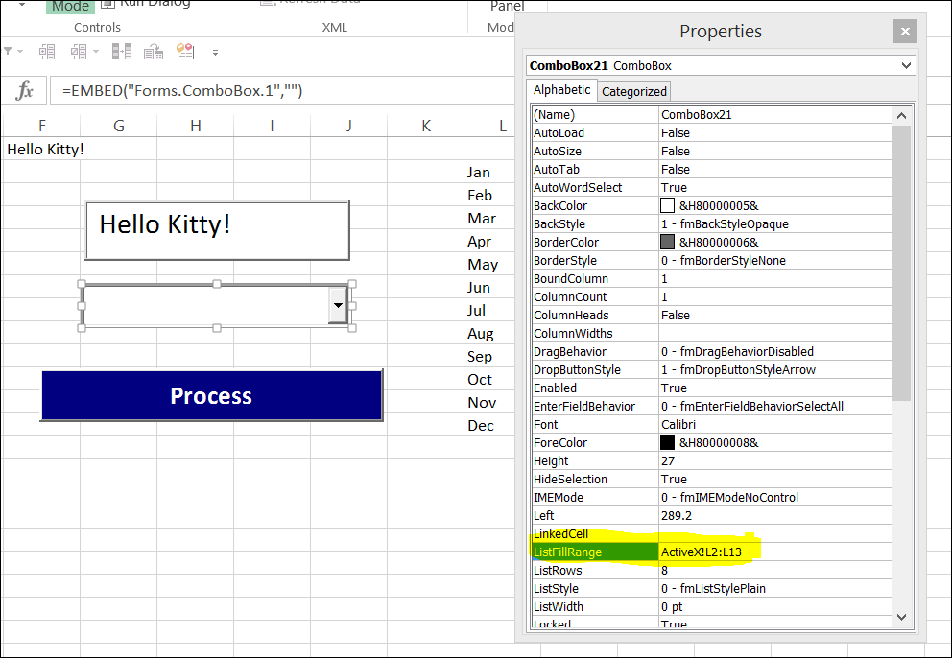

Double click on the "Process" button to change the code to

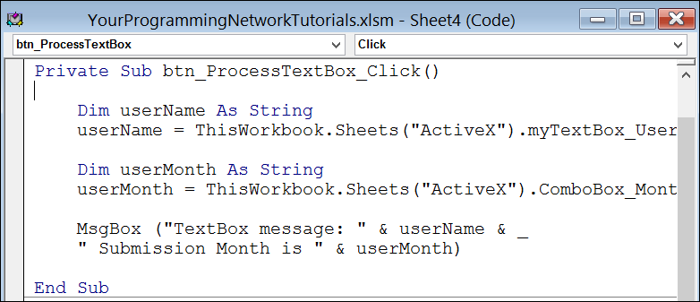

'=======================================================================

Private Sub btn_ProcessTextBox_Click()

Dim userName As String

userName = ThisWorkbook.Sheets("ActiveX").myTextBox_UserName.Value

Dim userMonth As String

userMonth = ThisWorkbook.Sheets("ActiveX").ComboBox_Months.Value

MsgBox ("TextBox message: " & userName & _

" Submission Month is " & userMonth)

End Sub

'=======================================================================

Turn off the Design Mode and press "Process" button to run the program

